Designing a
stakeholder engagement plan for Urban Air Mobility (UAM) Integration in Hong Kong

Student Name:Yan Yixuan
Student ID:25107505g

1.Introduction
Hong Kong has inherently constrained airspace resources.As an international aviation hub, its core facility—Hong Kong International Airport (HKIA)—handled 599,800 flight movements in the 2023-2024 fiscal year, representing a 103.2% year-on-year increase(Civil Aviation Department, 2022)^{[1]}.The low-altitude airspace currently accommodates approximately 20 commercial helicopters and 12 aircraft operated by the Government Flying Service (for search and rescue, medical evacuation, etc.), and Hong Kong has achieved globally leading airspace utilization efficiency Civil Aviation Department [CAD], 2024)^{[2]}.Low-altitude routes must be strictly separated from high-altitude civil aviation routes, which complicates route planning and safety coordination for the Ma Wan-Central eVTOL route(Civil Aviation Department, 2022)^{[1]}.
Land commuting between Ma Wan and Central relies on core cross-district corridors:Tsing Ma Bridge-Tsing Yi Highway-Cheung Tsing Highway-Nam Wan Tunnel-West Kowloon Highway– Western Harbour Crossing- Connaught Road West (Figure 1).Daily traffic volumes on these core cross-district corridors have approached or exceeded design capacity.Commuting via public transport requires transferring from NR332 (via Tsing Yi North Waterfront Road) to the Tsuen Wan Line,or selecting the cross-harbor bus NR338S from Ma Wan to Central (Figure 2).
Figure 1 Commuting by car Figure 2 Commuting by public transportation
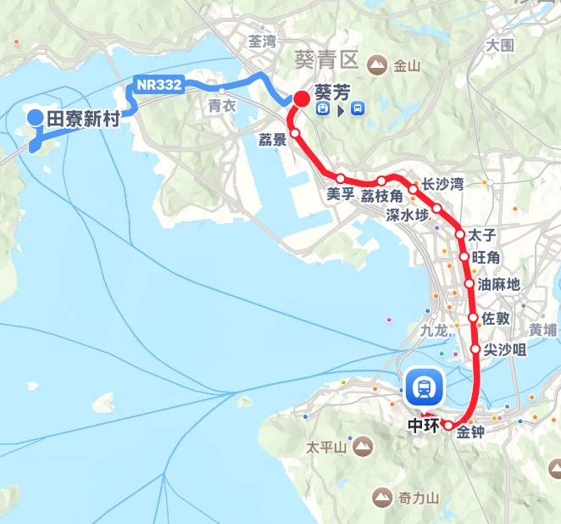
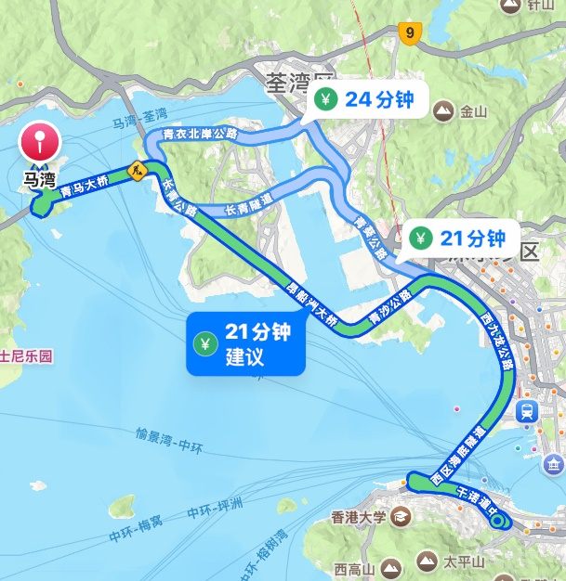

In July 2025,the proportion of delayed cross-harbor bus services (including routes such as NR338S) from Ma Wan to Central reached 18% on average daily,with over 30% of services delayed during peak hours (Transport Department, 2024)^{[3]}.For those who commute entirely by private vehicle,the Western Harbour Crossing—a mandatory route for this journey—is projected to handle an average daily two-way traffic volume of 98,500 vehicles in July 2025,far exceeding its design capacity of 80,000 vehicles per day (Transport Department, 2025a)^{[4]}.During the morning peak (08:00-09:00),hourly traffic volume for northbound private vehicles reaches 3,400 vehicles.During the evening peak (18:00-19:00),southbound hourly traffic volume reaches 3,200 vehicles.Queues frequently exceed 1 kilometer in length,resulting in low traffic efficiency.During the 2024 morning rush hour (08:00-09:00),the average travel speed on this route was only 28 km/h (compared to approximately 60 km/h under normal conditions),with the entire journey taking about 45-55 minutes.During the evening rush hour (18:00-19:00),congestion on Connaught Road West eastbound (average daily traffic volume:24,200 vehicles; peak hourly traffic volume:1,870 vehicles) further extended travel time to 60-70 minutes (Transport Department, 2025b)^{[5]} (Transport Department, 2025c)^{[6]}.
The commercia air-taxi service of Mobile AeroJet HK,has been granted an operational approval by the HKSAR Government to launch a commercial air-taxi service in Hong Kong.Compared to the pain points of existing land-based commuting—high congestion,long durations,and low reliability—the eVTOL low-altitude direct flight solution from Ma Wan to Central covers a distance of approximately 16 kilometers.With an average flight speed of about 120 km/h,the entire journey takes only 8-10 minutes.This represents an over 85% efficiency improvement compared to peak-hour commutes—1.5 hours by bus and 1 hour by subway.
Insufficient stakeholder participation is the primary cause of failure in global UAM projects, with the case of German company Volocopter—forced to halt its air taxi promotion in Singapore—serving as a prime example.In 2023, it suspended the program, directly due to a lack of local financial partners.Underlying factors included inadequate urban infrastructure for operations,low public demand (since Singapore’s traffic congestion is relatively manageable),and weak investor and public confidence
This plan aims to identify the core stakeholder demands for the Ma Wan-Central route in Hong Kong by analyzing failed cases of global Urban Air Mobility (UAM) projects,with the Volocopter Singapore project as a key example.It further intends to design implementable engagement strategies to mitigate the risk of "technical feasibility but insufficient social adaptability," thereby ensuring the project aligns with the strategic goal of "three-dimensional transportation demonstration" outlined in the Hong Kong Smart City Blueprint 2.0.

2.Lessons learned from failure
Volocopter's air taxi pilot project in Singapore's Marina Bay,which began with an optimistic start in October 2019 with manned test flights,was suspended in 2023 due to a lack of local funding partners and insufficient public support.Considering the specific operational context of this project,the following key lessons have been identified.
Regarding community engagement,Volocopter's core misstep lay in its delayed and ambiguous response to “noise and safety concerns.” During its 2019 public test flights in Singapore's Marina Bay,while touting the eVTOL model as “low-noise,”the project did not disclose actual noise measurement data to nearby residents.It merely stated that “the sound is inaudible beyond 700 meters.” No specific decibel levels were provided,and Volocopter's noise sources originate from its 18 rotors (Figure 3).The impact of high-frequency,close-range flights on residents' daily lives was also not addressed(INABR, 2022)^{[9]}.
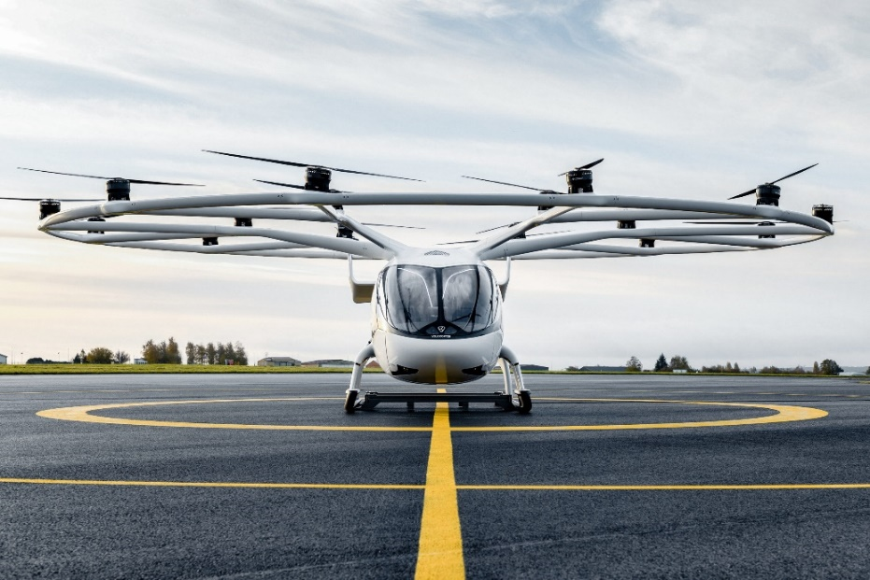
Figure 3 Volocopter Model
At the regulatory coordination level,the Volocopter project failed to establish a regular communication mechanism with the Civil Aviation Authority of Singapore (CAAS) and the Economic Development Board (EDB),resulting in a disconnect between project advancement and regulatory compliance.Despite initial support as a “Smart City Benchmark Project” from Singaporean authorities,subsequent scaling plans failed to promptly share “airspace route adjustment proposals” and “multi-aircraft scheduling procedures” with CAAS.Similarly,EDB was not consulted on “infrastructure funding allocation models.” Ultimately,the project stalled due to “regulatory compliance concerns” and an “unbridgeable funding gap.”
Regarding investor and public confidence cultivation,Volocopter's critical misstep was failing to demonstrate the relevance of UAM services to Singapore's transportation needs,undermining investor confidence in the project's viability.Singapore's relatively low ground traffic congestion created insufficient public urgency for “air taxis” (Straits Times, 2023)^{[7]}.Additionally,the nation's biannual monsoon seasons—marked by months of heavy rain and thunderstorms—necessitate flight suspensions during severe weather.This further restricts eVTOL application scenarios,complicating capital recovery.Public concerns persist regarding privacy impacts from eVTOL high-altitude operations (Jia, Chen & Tian, 2003)^{[10]}.Volocopter neither presented investors with “market demand research data” nor cultivated consumer awareness through public experience events to offer reasonable solutions to these concerns.

3.Stakeholder analysis
This stakeholder analysis employs the Mitchell scoring method (Jia, Chen & Tian, 2003)^{[10]},with specific correspondences detailed in Table 1.

Table 1 Mitchell scoring
Hierarchy | Mitchell classification | Adaptation Logic
Core decision-making body | Determinate type | The Civil Aviation Department/Transport Department holds project approval authority (authoritative),represents public interests (legitimate),and makes decisions that directly determine project viability (urgent),making it a group that “must be prioritized for response.”
Directly affected layer | Anticipatory | Residents'/businesses' demands align with public interest (legitimacy),protests/complaints directly impede project progress (urgency),but lack approval authority (limited power),necessitating proactive communication to resolve.
Indirect Association Layer | Latent | Investors wield financial influence (power),while environmental NGOs represent ecological interests (legitimacy).However,their demands do not necessitate immediate project termination (relatively low urgency),requiring long-term collaborative maintenance.

The core decision-making bodies are the Civil Aviation Department (CAD) and the Transport Department,which possess legitimacy,authority,and urgency.
The core objectives are to safeguard airspace security,ensure regulatory compliance,and integrate with urban transportation planning.Currently,the CAD has classified eVTOLs under Category C regulation under the Small Unmanned Aircraft Order.However,specific operational details—such as low-altitude flight path priority and emergency response responsibility allocation—remain to be clarified.The project team must proactively establish a 'monthly regulatory communication meeting' mechanism,submit materials (including the 'Ma Wan-Central Route Airspace Isolation Plan' and the 'Hong Kong International Airport Approach Route Avoidance Procedures'),and concurrently apply for flight permits and third-party safety certifications.This prevents project delays caused by ”delays in aligning with regulatory rules." The Transport Department focuses on the project's role in supplementing cross-district transport capacity,requiring alignment with the Hong Kong Transport Development Strategy 2025.Potential conflicts may arise from information delays—failure to submit route adjustment plans in advance could delay operational permits.Questions regarding coordination with existing public transport may also impact implementation pace.This layer directly determines project eligibility and holds the highest priority.
The directly affected layer comprises residents of Ma Wan/Central communities and surrounding businesses.Both Ma Wan (near Tsing Yi) and Central landing sites are surrounded by high-density residential areas (including Ma Wan Pearl Harbour and Central Mid-Levels residential zones),necessitating heightened vigilance against “community resistance triggered by noise pollution.” Hong Kong has entered a super-aged society,with seniors aged 65 and above accounting for 21% of the population in 2023 (Figure 4).This demographic exhibits heightened sensitivity to daytime rest environments.Project developers must disclose eVTOL takeoff and landing noise data during the site selection phase.The Permission to Conduct Trial Operations of Unconventional Aircraft (Aeronautical Information Service, 2025)^{[12]} (AIC 20/25 2025) establishes noise standards for the trial phase of Hong Kong's UAM projects:
Within 100 meters of take-off and landing sites:The equivalent continuous A-weighted sound level (Leq,15min) shall be ≤65 dB(A);
When the cruise path is ≥150 meters away from sensitive areas:The instantaneous maximum noise shall be ≤70 dB(A).
Meanwhile,attention shall also be paid to operational support and passenger flow.Construction of takeoff/landing sites that occupy parking spaces or block entrances may cause revenue losses.Clear shuttle routes and promotional plans must be established to avoid compensation disputes.Regarding privacy protection,eVTOL models should be required to ship with cabin window-area camera permissions disabled by default (including passenger phone signal jamming and externally mounted cameras locked in fixed orientation),retaining only “flight safety-essential aerial survey cameras.” Camera fields of view must be strictly limited to “forward-facing nose+underside of fuselage (avoiding residential window directions).” with captured data exclusively used for route planning and fault tracing,prohibited for commercial or other purposes.Alternatively,a “low-altitude privacy algorithm” could be implemented—using AI to recognize residential building outlines and automatically adjust camera focus and angles to avoid capturing interior views.Simultaneously,a “privacy protection airspace” should be established within a 500-meter radius of takeoff/landing points,prohibiting any non-safety-related camera activation.Such technical solutions must undergo prior review and filing with Hong Kong's Privacy Commissioner for Personal Data (PCPD).Collaborate with the Hong Kong Civil Aviation Department and Department of Justice to establish clear “privacy infringement criteria.”For instance,if eVTOL flights leak residents' private footage due to equipment failure or human error,project operators face penalties of “up to HK$500,000 fines plus victim compensation.” Passengers violating filming regulations will be placed on a “UAM service blacklist,” permanently barred from future flights.
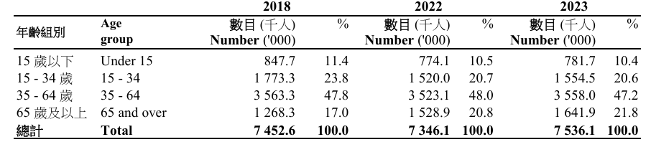
Figure 4 Age Structure of Hong Kong's Population from 2021 to 2023 (Census and Statistics Department, 2024)^{[8]}

The indirect stakeholder group includes investors,MTR/helicopter operators,and environmental NGOs.Investors require clear passenger flow,subsidy,and cost data to mitigate profitability risks; MTR is concerned about diverting Tsuen Wan Line passengers,while helicopter operators need explicit airspace avoidance rules.Public disclosure of carbon emissions and battery recycling plans must align with the Hong Kong Climate Action Blueprint 2050 to prevent environmental backlash.Simultaneously,the project must leverage Hong Kong's significant cross-district commuting challenges.Land commutes from Ma Wan to Central exceed one hour during peak hours,while Hong Kong International Airport's annual passenger volume has recovered to 85% (Civil Aviation Department [CAD], 2024)^{[2]}of pre-pandemic levels.cross-border commuting demand is robust.Project developers should disclose to investors 'Ma Wan-Central route passenger flow projections' (e.g.,average daily potential ridership,fare affordability studies) to investors.Following the model of Hong Kong MTR's “public trial rides” for high-speed rail,static eVTOL displays and simulated flight experiences should be conducted at Central Pier.Concurrently,collaborate with MTR to design “eVTOL + MTR transfer” solutions,enhancing investor confidence through “tangible,verifiable demand.”
To address Hong Kong's annual monsoon season,the current Small Unmanned Aircraft Order (Cap.448G) (Civil Aviation Department [CAD], n.d.)^{[11]} stipulates that small unmanned aircraft shall not be flown when rainstorm warnings,tropical cyclone warnings,or strong monsoon signals are in effect.To ensure normal flight operations under weather conditions other than the aforementioned ones, "temporary vertical take-off and landing (VTOL) sites" may also be reserved within a 1-kilometer radius of the take-off and landing sites in Ma Wan and Central—such as vacant parking lots or rooftop platforms.When main terminals close due to weather, activate these sites for “short-haul shuttle flights” (e.g., Ma Wan-Tsing Yi, Central-Sheung Wan) to reduce cancellation rates.Passengers experiencing delays exceeding one hour due to weather conditions will receive a “20% discount coupon for their next flight + a HK$50 dining voucher,” mitigating negative experiences.Establishing tiered response protocols ensures the majority of flight routes operate normally while maintaining safety, thereby guaranteeing predictable profitability.

4.Engagement Strategy and Plan
To address the issues identified in the stakeholder analysis—including the Civil Aviation Department (CAD)/Transport Department’s regulatory compliance requirements,communities’ concerns over noise and privacy,and trust gaps with merchants and investors—and align with Hong Kong’s local characteristics,this strategy is implemented in three phases.
Early Planning Phase (3–6 Months)
This phase focuses on fixing the core flaws of the Volocopter project—delayed regulatory communication and inadequate public engagement—while responding to the needs of key stakeholders.For the CAD,a core decision-maker focused on airspace safety,biweekly coordination meetings will be held to submit the Ma Wan-Central Route Airspace Isolation Plan.In line with AIC 20/25 requirements,this plan ensures a 1-kilometer safety interval from Hong Kong International Airport’s flight routes (Civil Aviation Department [CAD], 2024) ^{[2]}.Additionally,a monthly eVTOL Technical Compliance Report (including battery cycle test data and obstacle avoidance algorithm updates) will be submitted,and the CAD will be invited to participate in airspace simulation drills.
For the Transport Department,the Traffic Coordination Analysis Report will be submitted to demonstrate that eVTOLs can reduce private car traffic by 15%,which aligns with the Hong Kong Transport Development Strategy 2025.
For communities—the directly affected group—three public consultation meetings will be held.Commitments will be made to meet AIC 20/25 noise standards and ban flights between 21:00 and 07:00.It will be clarified that eVTOL on-board cameras will use AI to blur the windows of residential buildings,and a 500-meter “privacy protection zone” will be designated.
For investors—indirect stakeholders—a feasibility report will be released,highlighting the “passenger flow forecast with 40% of low- and middle-income groups.” An investor briefing will also be held,using data comparing land commuting time (45–70 minutes) and eVTOL commuting time (8–10 minutes) (Transport Department, 2024)^{[3]} to prove market demand,addressing the Volocopter project’s flaw of “insufficient demand verification.”
Mid-Term Construction Phase (6–12 Months)
This phase focuses on mitigating risks identified in the stakeholder analysis—such as “merchant revenue losses” and “poor accessibility for low- and middle-income groups”—while avoiding the Volocopter project’s issue of “lengthy certification processes.”
For Ma Wan/Central merchants,Support Agreements will be signed with 15 key merchants,offering a 10% rent reduction and priority rights for in-flight advertising.
For low- and middle-income residents,two transit hubs will be set up in Ma Wan’s public housing areas,with free shuttle minibuses running every 8 minutes to connect to take-off and landing sites.In collaboration with local merchants,“eVTOL consumer vouchers” will be launched—for example,a HK$10 discount for every HK$50 spent with a commuter certificate—to enhance inclusivity.
To avoid the Volocopter project’s “certification delays,” a third-party organization (e.g.,Hong Kong Quality Assurance Agency) will be commissioned to conduct pre-audits of eVTOL safety,focusing on battery durability and emergency landing systems.Audit results will be shared with the CAD monthly to ensure compliance with EASA CS-27 standards (Aeronautical Information Service, 2025)^{[12]},which will shorten the official certification cycle.
Long-Term Operation Phase (12+ Months)
Based on potential risks during the operation period,a risk response plan (Table 2) is designed to ensure the long-term stability of the project during the operation phase.
Table2 Risk Response Plan
Risk Type | Trigger Condition | Response Measures
Technical Failure | eVTOL battery abnormality requiring emergency landing | Activate the temporary landing site in Ma Wan - Tsing Yi, dispatch shuttle minibuses to transfer passengers within 10 minutes, and notify CAD simultaneously.
Community Protest | Monthly noise complaints exceed 10 | Temporarily adjust flight routes (via Victoria Harbour), and cooperate with environmental NGOs to hold "Noise Science Popularization Days".
Merchant Withdrawal | More than 3 livelihood merchants terminate cooperation. | Urgently cooperate with the Ma Wan Chamber of Commerce to recruit alternative merchants, and temporarily increase the "HK$15 off for every HK$50 spent" consumer voucher discount.
Capital Withdrawal | Concerns about profitability. | Publish the Inclusive Operation Profitability Analysis Report semi - annually (explaining the cost - covering logic of subsidies + economies of scale).
For CAD,quarterly reports will focus on explaining emergency landing plans during monsoon weather such as typhoons and heavy rains; for communities,real - time noise data ensures compliance with AIC20/25 standards (Aeronautical Information Service, 2025)^{[12]};for merchants and investors,long - term project feasibility is guaranteed through dynamically adjusting cooperation plans and transparent data disclosure.

5.Conclusion
The Hong Kong MobileAeroJetHK “Ma Wan-Central eVTOL Route” project represents both an innovative attempt to alleviate cross-district commuting congestion and a pivotal practice for implementing Urban Air Mobility (UAM) in high-density urban areas.From a stakeholder perspective,the project's success hinges on precisely addressing the Civil Aviation Department's regulatory compliance requirements,community residents' livelihood concerns,and the interests of businesses and investors. This approach effectively mitigates potential conflicts such as airspace safety,noise disputes,and resource competition.
The phased implementation plan and safeguarding mechanisms further support project execution:early-stage risk prevention reduces launch resistance,mid-term dynamic responses minimize construction friction,and long-term maintenance in the later stages solidifies operational foundations.Meanwhile,the coordination committee and emergency response team provide buffers for unexpected disputes.Ultimately,by consistently prioritizing stakeholder collaboration,the project can not only achieve sustainable operations but also establish a UAM demonstration model for Hong Kong's “multi-modal three-dimensional transportation” system,thereby advancing the implementation of the “Smart Aviation Hub” strategy.

Reference
[1]Civil Aviation Department,Government of the Hong Kong Special Administrative Region,2022. Hong Kong:The Facts. Hong Kong:Civil Aviation Department.
[2] Civil Aviation Department,Government of the Hong Kong Special Administrative Region (CAD),2024. Annual Report 2023-2024:Chapter 4 - Air Traffic and Infrastructure Development. [online] Available at:https://www.cad.gov.hk/reports/an2023-2024/html/sc/ch4.html [Accessed 15 October 2025].
[3] Transport Department,Government of the Hong Kong Special Administrative Region (Management Services Division),2024. Cross-Harbour Passenger Volume by Selected Public Transport Operators (2024 Q3). Hong Kong:Transport Department.
[4] Transport Department,Government of the Hong Kong Special Administrative Region (Management Services Division),2025. Western Harbour Crossing Traffic Data Report (July 2025). Hong Kong:Transport Department.
[5]Transport Department,Government of the Hong Kong Special Administrative Region (Management Services Division),2025. Connaught Road West. Transport Data Report,July. Hong Kong:Transport Department.
[6]Transport Department,Government of the Hong Kong Special Administrative Region (Management Services Division),2025. South Bay Tunnel. Transport Data Report,July. Hong Kong:Transport Department.(July 2025)
[7]Straits Times,2023. Lack of local funding partners forces Volocopter to put air taxi launch in Singapore on hold. [online] Available at:https://www.straitstimes.com/singapore/transport/lack-of-local-funding-partners-forces-volocopter-to-put-air-taxi-launch-in-singapore-on-hold?ref=search-results [Accessed 20 August 2025].
[8]Census and Statistics Department,Government of the Hong Kong Special Administrative Region,2024. Hong Kong in Figures (2024 Edition). Hong Kong:Census and Statistics Department.
[9]INABR,2022. Volocopter eVTOL Noise Concerns Delay Singapore Project: Lessons for Hong Kong UAM. [online] Available at: https://inabr.com/news/8298 [Accessed 5 July 2025]. [10]Jia,S.H.,Chen,H.H. and Tian,C.H.,2003. Enterprise performance evaluation based on stakeholder theory:An analytical framework and application research. Scientific Research Management,24 (4),p.8. (In Chinese; Romanised title with original Chinese title:基于利益相关者理论的企业绩效评价——一个分析框架和应用研究)
[11]Civil Aviation Department (Hong Kong Special Administrative Region) [CAD]. (n.d.). Safety Guidelines for Small Unmanned Aircraft (SUA).[Online].Available at:https://www.cad.gov.hk/chinese/sua_safetyreg_safetyguidelines.html [Accessed 6 October 2025].
[12]Aeronautical Information Service (Hong Kong Special Administrative Region). (2025). Permission to Conduct Trial Operations of Unconventional Aircraft in Hong Kong (Aeronautical Information Circular No. AIC 20/25). Hong Kong:Aeronautical Information Service.

